Analysis of Comprehensive Web Traffic Dataset

Victor Alexander Peluso

Created: January 5th, 2025

Updated: January 22nd, 2025

**Table of Contents**

**Introduction**

**Methodology**

Data Collection

Tools and Technologies

Analysis Techniques

**Data Visualization & Analysis**

Histogram of Session Duration

Box Plot of Session Duration

Traffic Sources Distribution

1. Organic Traffic:

2. Paid Traffic:

3. Referral, Social, and Direct Traffic:

Session Duration vs. Conversion Rate

1. Positive Correlation:

2. Cluster and Outliers:

3. Strategic Implications:

Correlation Heatmap

1. Conversion Rate and Session Duration:

2. Conversion Rate and Time on Page:

3. Conversion Rate and Page Views:

4. Conversion Rate and Previous Visits:

5. Other Relationships:

**Results**

Session Duration Distribution

Session Duration Summary

Traffic Sources Distribution

Conversion Rate and Session Duration

Correlation Insights

**Recommendations**

1. Enhance Content Quality

2. Improve User Experience

3. Optimize SEO Strategies

4. Refine Paid Advertising Campaigns

5. Leverage Referral and Social Channels

6. Monitor and Analyze Outliers

7. Implement Retargeting Campaigns

**Limitations**

**Future Work**

**Conclusion**

# Introduction

In the digital age, understanding user behavior through data analysis is essential for optimizing website performance and enhancing user engagement. This section leverages various data visualization techniques to explore key insights into user interactions, traffic sources, and conversion patterns on the website. By employing histograms, box plots, bar charts, and heatmaps, we aim to uncover meaningful trends and correlations that can inform strategic decisions.

Each visualization offers a unique perspective: the histogram and box plot shed light on session duration distributions and outliers, the bar chart delineates the traffic source composition, and the heatmap provides a comprehensive overview of variable correlations. Together, these analyses not only illustrate the current state of user engagement but also suggest actionable strategies for improvement, guiding efforts to enhance user experience, optimize marketing campaigns, and increase conversions.

# 

# 

# Methodology

In this section, we describe the processes and techniques employed in analyzing the dataset to derive insights about website traffic, user behavior, and conversion rates. The steps include data collection, preprocessing, and visualization techniques.

#### **Data Collection**

The dataset used in this analysis was sourced from [Kaggle](https://www.kaggle.com/datasets/anthonytherrien/website-traffic). It comprises 2,000 records detailing various aspects of user interactions with the website, such as session durations, traffic sources, conversion rates, and more.

#### **Tools and Technologies**

* **Python**: Used for data preprocessing, statistical analysis, and visualization.
* **Tableau**: Utilized for creating interactive visualizations to better understand the relationships between different variables.
* **Libraries**: Pandas for data manipulation, Matplotlib and Seaborn for static visualizations.

#### **Analysis Techniques**

* **Descriptive Statistics**: Basic statistical measures (mean, median, mode) were computed to summarize the central tendency, dispersion, and shape of the dataset's distributions.
* **Visualization**: Various charts and plots, including histograms, box plots, bar charts, and heatmaps, were used to visually represent data patterns and relationships between variables.
* **Correlation Analysis**: Pearson correlation coefficients were calculated to identify and quantify relationships between variables, aiding in understanding which factors are most associated with conversion rates.

# 

# 

# Data Visualization & Analysis

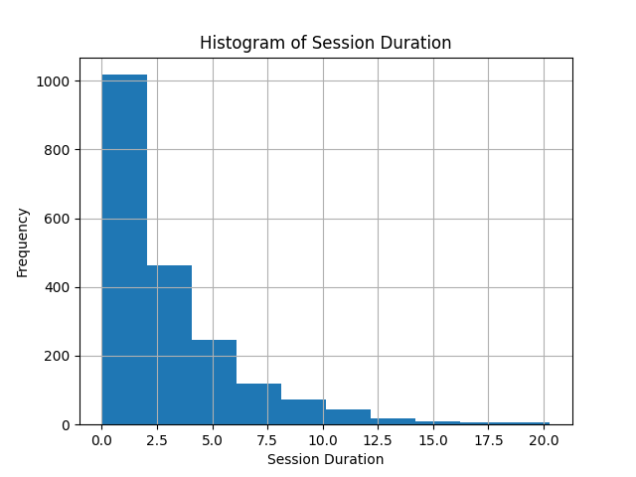

## Histogram of Session Duration

The histogram offers a visual representation of the distribution of session durations across various time intervals, providing an intuitive way to observe how session lengths are spread out from shortest to longest.

The **left-skewed nature** of the data indicates that most session durations are concentrated towards the shorter end of the spectrum, with the vast majority of sessions lasting no more than 2 ½ minutes. This skewness suggests that many users spend only a brief amount of time on the website, which could point to either efficient navigation for quick information retrieval or potential issues with user engagement.

By examining this distribution, we can identify the typical session length that most users experience and observe any notable deviations. The histogram highlights the prevalence of short sessions, which dominate the dataset, while longer sessions are less common and could represent a smaller, more engaged subset of users.

This insight into session duration distribution is crucial for informing **marketing campaigns and website design strategies**. For example:

* **Marketing campaigns** can be tailored to attract more engaged users who are likely to spend longer periods on the site, potentially leading to higher conversion rates.
* **Website redesigns** could focus on enhancing user experience by providing more engaging content or improving site navigation, aiming to lengthen session durations where appropriate.

Moreover, tracking changes in the distribution of session durations over time allows for a **dynamic assessment** of the impact of these strategies. If the goal is to increase the average session duration, observing shifts in the histogram post-implementation can provide direct feedback on the effectiveness of these changes. Conversely, if shorter sessions are preferred for efficiency, adjustments can be made to streamline the user journey further.

Overall, the histogram serves as a foundational tool for understanding user behavior and guiding data-driven decisions to optimize the balance between session length and user engagement.

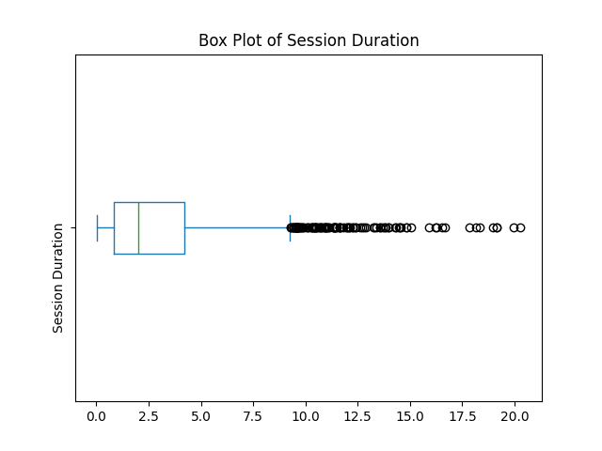

## Box Plot of Session Duration

The box plot provides a further detailed visualization (over the Histogram) of the distribution of session durations on the website, revealing key statistical summaries such as the median, interquartile range (IQR), and outliers.

The **median session duration** is just under 2 ½ minutes, meaning that half of all user sessions last less than this time. This central tendency suggests that a typical user's interaction with the website is relatively brief, potentially indicating either quick navigation or a lack of engagement, depending on the website's goals.

The **interquartile range (IQR)**, which spans from the 25th to the 75th percentile, shows that 50% of the sessions are between approximately 1 and 4 minutes. This range provides insight into the variability of user engagement, suggesting a moderate spread in session durations among the majority of users.

The **outliers**, represented by dots beyond the whiskers of the plot, indicate sessions that significantly exceed the usual duration. These outliers could correspond to users who spent an unusually long time on the site, possibly exploring content in-depth or encountering technical issues that prolonged their session. Further investigation into these outliers could uncover valuable insights, such as identifying highly engaged users or addressing potential usability problems.

This analysis of session duration can inform strategies aimed at optimizing user engagement. For instance, if the goal is to increase the average session duration, efforts could focus on enhancing content quality, improving navigation, or offering more engaging interactive features. Conversely, if shorter, efficient sessions are preferred, the data can help streamline the user experience to facilitate quicker access to key information or actions.

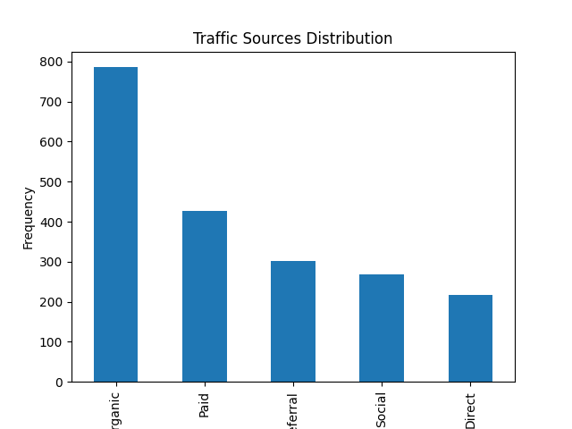

## Traffic Sources Distribution

The bar chart provides a clear visualization of the **distribution of website traffic sources**, categorized into five primary groups: **Organic, Paid, Referral, Social,** and **Direct**. This breakdown offers valuable insights into how users are arriving at the website and the effectiveness of various traffic channels.

### Organic Traffic:

* + **Organic traffic** is the most significant contributor, accounting for nearly **800 records** out of the total **2,000 data points**. This dominance underscores the website's **strong performance in organic search results**, likely due to effective **search engine optimization (SEO)** strategies. The high volume of organic visitors indicates that the website is well-optimized for search engines, making it easily discoverable to users searching for relevant keywords or topics.

### Paid Traffic:

* + **Paid traffic**, which comes in second with just over **400 records**, contributes to about **20%** of the total traffic. Although this is **half the volume of organic traffic**, it still represents a significant portion, showing the impact of **paid advertising** campaigns. This suggests that while **pay-per-click (PPC)** ads and other paid marketing efforts are bringing in visitors, there may be room to optimize these campaigns further to increase their effectiveness or reach.

### Referral, Social, and Direct Traffic:

* + The remaining traffic sources—**Referral, Social, and Direct**—contribute smaller but still crucial segments of the overall traffic. These channels represent users arriving through **external links (Referral)**, **social media platforms (Social)**, and direct visits, such as typing the URL into the browser or using bookmarks (Direct). Each of these channels can play a pivotal role in driving targeted traffic and diversifying the website's audience base.

The combined share of **Organic and Paid traffic** constitutes over **60%** of the total traffic, emphasizing the **importance of balancing both organic and paid strategies** in the marketing mix. The data suggests that while organic reach is currently more impactful, paid advertising still plays a crucial supporting role.

This distribution can guide the business in making **informed decisions** about resource allocation for traffic acquisition. For example, if the goal is to increase overall traffic quickly, investing more in **paid campaigns** could yield immediate results. Conversely, focusing on **SEO** could sustain long-term organic growth.

**Enhancing SEO efforts** further could continue to bolster organic traffic, while analyzing the effectiveness of current **paid campaigns** could lead to better ROI and increased paid traffic.

Exploring the **Referral and Social channels** more deeply could uncover untapped opportunities for growth, such as partnerships with other websites or more targeted social media strategies.

In summary, the bar chart not only visualizes the **current traffic distribution** but also serves as a strategic tool for **assessing the performance** of different traffic sources. It highlights where the website is thriving and where there might be opportunities for growth, helping the business to prioritize its marketing efforts effectively.

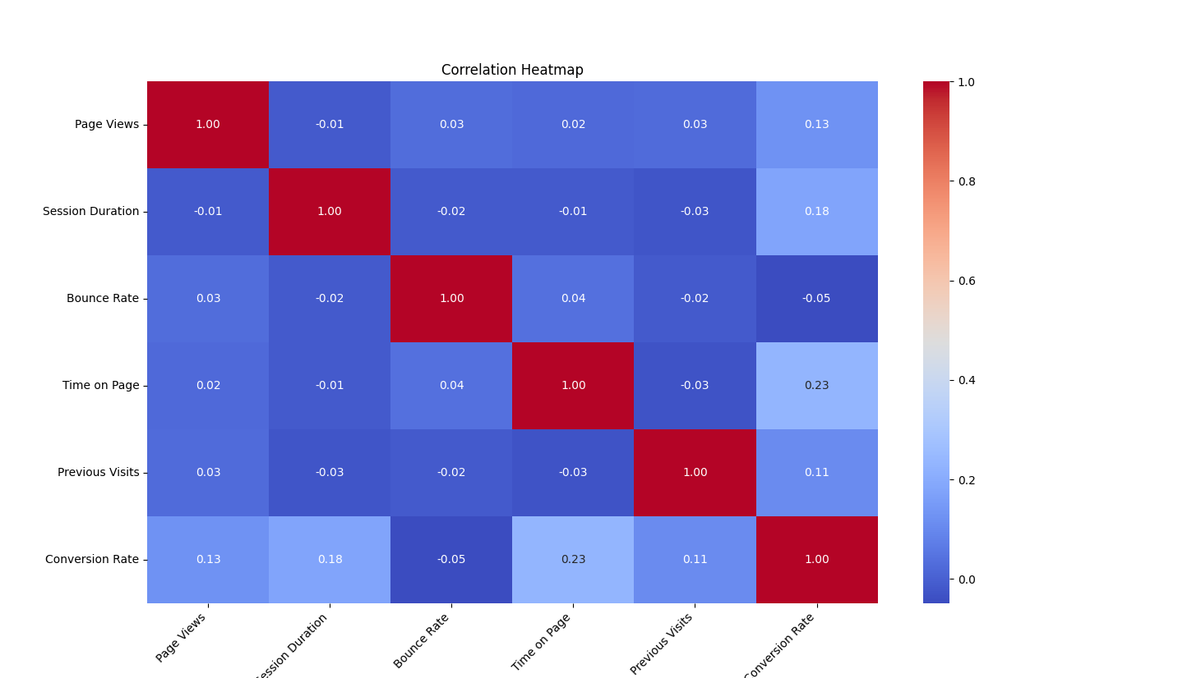

## Correlation Heatmap

The heatmap offers a visual representation of correlations between key variables in the dataset. It uses a color gradient to depict the strength and direction of these correlations, with darker shades indicating stronger relationships. This visualization is particularly useful for identifying variables that move together and those that do not, which can guide marketing and business strategies.

### Conversion Rate and Session Duration:

* + The heatmap reveals a positive correlation of 0.18 between Session Duration and Conversion Rate. While this correlation is moderate, it suggests that longer session durations are generally associated with higher conversion rates. This insight implies that strategies aimed at increasing the time users spend on the website could potentially lead to improved conversion outcomes. For instance, enhancing the user experience or providing more engaging content might encourage users to stay longer and increase their likelihood of converting.

### Conversion Rate and Time on Page:

* + The correlation between Time on Page and Conversion Rate is the highest among the relationships, at 0.23. This indicates a stronger, though still moderate, positive correlation, suggesting that the longer a user spends on individual pages, the more likely they are to convert. This can direct efforts to optimize content on high-traffic pages, ensuring they are compelling enough to keep users engaged, which could improve conversion rates.

### Conversion Rate and Page Views:

* + There is a positive correlation of 0.13 between Page Views and Conversion Rate, indicating that users who view more pages during their sessions are somewhat more likely to convert. Although the relationship is weaker compared to others, it still supports the idea that encouraging users to explore multiple pages—perhaps through better site navigation or relevant internal linking—could slightly boost conversion rates.

### Conversion Rate and Previous Visits:

* + The correlation between Previous Visits and Conversion Rate is 0.11, suggesting that users with more previous visits are marginally more likely to convert. This reinforces the importance of retargeting and engagement strategies that bring users back to the site, as returning visitors may be more familiar with the offerings and closer to making a purchase or completing a desired action.

### Other Relationships:

* + The remaining relationships show weak correlations, ranging from 0.04 to -0.03. These near-zero values indicate little to no linear relationship between the variables, suggesting that these factors do not significantly influence each other in a way that can be captured by correlation alone. For example, there might not be a strong linear relationship between Bounce Rate and Time on Page, indicating that users might leave after viewing one page regardless of how long they spend on it.

The heatmap highlights areas where the business can focus its efforts to improve conversion rates. Since Session Duration and Time on Page have the highest correlations with Conversion Rate, strategies that aim to increase engagement and keep users on the site longer are likely to be more effective.

While the correlations are not exceptionally strong, they provide directional guidance for marketing efforts. For example, content marketing and UX enhancements could be prioritized over other strategies due to their potential impact on session duration and page engagement.

* Enhance content quality and relevance to ensure users find value in spending more time on individual pages.
* Improve site navigation and internal linking to encourage users to view more pages during their sessions.
* Implement personalized retargeting campaigns to re-engage users who have previously visited the site, increasing the chances of conversion upon their return.

In summary, the heatmap serves as a powerful tool for identifying key relationships between variables. It provides actionable insights that can be used to refine marketing strategies and optimize website performance to enhance user engagement and conversion rates.

# 

# 

# 

# 

# 

# 

# 

# Results

# 

This section presents the key findings from the data analysis and visualization. Each result corresponds to specific insights gained from the different visualization techniques applied.

#### **Session Duration Distribution**

* **Histogram Analysis**: The histogram revealed a left-skewed distribution of session durations, with the majority of sessions lasting less than 2 ½ minutes. This suggests a prevalence of short visits, indicating either efficient user navigation or potential issues with engagement.

#### **Session Duration Summary**

* **Box Plot Analysis**: The median session duration is slightly less than 2 ½ minutes, with the interquartile range indicating that 50% of sessions fall between approximately 1 and 4 minutes. Outliers in the data represent unusually long sessions, which may indicate highly engaged users or potential anomalies.

#### **Traffic Sources Distribution**

* **Bar Chart Analysis**: Organic traffic accounted for the largest share, nearly 800 records out of 2,000, highlighting effective SEO efforts. Paid traffic followed with over 400 records, contributing significantly to overall traffic, although less than Organic. Referral, Social, and Direct sources made up the remaining traffic, suggesting a diverse mix of user acquisition channels.

#### **Correlation Insights**

* **Heatmap Analysis**: The heatmap identified moderate positive correlations between conversion rate and other factors such as time on page (0.23) and session duration (0.18). These findings support strategies to enhance user engagement by extending session durations and time spent on individual pages.

# Recommendations

# 

Based on the findings from the data analysis and visualization, several strategic recommendations can be made to enhance user engagement and conversion rates.

#### **1. Enhance Content Quality**

* **Insight**: The positive correlation between session duration and conversion rate suggests that users who spend more time on the site are more likely to convert.
* **Recommendation**: Focus on creating high-quality, engaging content that encourages users to explore the website longer. This could include detailed product descriptions, engaging blog posts, and interactive media.

#### **2. Improve User Experience**

* **Insight**: The prevalence of short session durations indicates potential room for improvement in user engagement.
* **Recommendation**: Optimize the website's navigation and layout to make it more intuitive and user-friendly. Consider conducting usability tests to identify and address any pain points in the user journey.

#### **3. Optimize SEO Strategies**

* **Insight**: Organic traffic is the largest contributor to website visits.
* **Recommendation**: Continue to invest in SEO practices to maintain and improve organic search rankings. Regularly update content with relevant keywords, enhance meta descriptions, and ensure the site is mobile-friendly and fast-loading.

#### **4. Refine Paid Advertising Campaigns**

* **Insight**: Paid traffic, while substantial, is less than half of organic traffic.
* **Recommendation**: Review and refine paid advertising strategies to increase their effectiveness. This could involve targeting more specific demographics, optimizing ad copy and creatives, and adjusting bidding strategies to maximize ROI.

#### **5. Leverage Referral and Social Channels**

* **Insight**: Referral and social traffic constitute smaller portions of the overall traffic.
* **Recommendation**: Strengthen partnerships with other websites and enhance social media marketing efforts to increase traffic from these channels. Consider influencer partnerships, content collaborations, and more targeted social media campaigns.

#### **6. Monitor and Analyze Outliers**

* **Insight**: Outliers in session durations represent unusually long sessions that may indicate either highly engaged users or technical issues.
* **Recommendation**: Investigate these outliers to understand their cause. If they represent highly engaged users, identify common factors that can be applied to a broader audience. If they result from technical issues, address these promptly to ensure a smooth user experience.

#### **7. Implement Retargeting Campaigns**

* **Insight**: The positive correlation between previous visits and conversion rates suggests that returning users are more likely to convert.
* **Recommendation**: Use retargeting strategies to re-engage previous visitors, such as personalized email campaigns, dynamic remarketing ads, and special offers for returning users.

# Limitations

# 

Despite the valuable insights gained from this analysis, several limitations should be considered when interpreting the results:

1. **Sample Size**: The dataset contains 2,000 records, which provides a snapshot of user behavior but may not be representative of all website visitors. A larger dataset could offer more generalizable findings.
2. **Time Frame**: The data covers a specific period, and user behavior can vary over time due to seasonal trends, marketing campaigns, or changes in external factors. This temporal limitation might affect the applicability of the results to other periods.
3. **Lack of Contextual Data**: The dataset does not include demographic or psychographic information about users, which could provide deeper insights into different user segments' behaviors and preferences.
4. **External Influences**: Factors such as changes in search engine algorithms, social media trends, or competitors' activities could influence traffic sources and user engagement, but these are not accounted for in the dataset.
5. **Conversion Definition**: The analysis assumes a uniform definition of conversion, but conversions can vary significantly in their business impact (e.g., signing up for a newsletter vs. making a purchase). Websites often track multiple types of conversions, such as newsletter sign-ups, product purchases, account creations, or downloads, each with different value implications. Grouping all conversions together may obscure these distinctions, potentially leading to less targeted insights. A more granular approach, which differentiates between conversion types, could offer a refined understanding of what constitutes a valuable conversion and guide more precise optimization strategies.
6. **Data Quality**: Although the dataset was preprocessed and appeared spotless, any undetected anomalies or data collection errors could skew the results.
7. **Correlation vs. Causation**: While the heatmap reveals correlations between variables, these do not imply causation. Additional analyses or experiments would be needed to establish causal relationships.

These limitations highlight the need for careful interpretation of the findings and suggest areas for further research to enhance the robustness and applicability of the analysis.

# Future Work

# 

While the current analysis provides valuable insights into user behavior and traffic patterns, there are several areas for further exploration and improvement. Future work could expand upon the findings in this report by considering the following avenues:

1. **Granular Conversion Tracking:** As mentioned in the limitations section, conversions were treated as a single metric. Future analyses could break down conversions into distinct categories (e.g., purchases, newsletter sign-ups, account registrations) to gain a deeper understanding of user engagement and the effectiveness of different conversion types.
2. **Longitudinal Analysis:** A one-time snapshot of user behavior may not fully capture the impact of changes made to the website or marketing campaigns. A longitudinal approach, tracking user behavior over an extended period, would allow for a better understanding of how improvements and changes to the site influence session duration, conversion rates, and other metrics over time.
3. **User Segmentation:** To optimize marketing and user engagement strategies, it would be valuable to segment users based on various factors such as demographics, behavior patterns, or traffic sources. Analyzing the differences in conversion rates, session duration, and other key metrics between these segments could provide more targeted recommendations and improve the overall user experience.
4. **Predictive Modeling:** With additional data, predictive models could be developed to forecast future user behavior and conversions. By using techniques such as machine learning, it would be possible to predict the likelihood of a user converting based on their session behavior, allowing for more personalized marketing and website interventions.
5. **A/B Testing:** Future work could also include A/B testing for different website design and content strategies. By experimenting with various layouts, content types, and calls-to-action, it would be possible to determine which changes have the most significant impact on user engagement and conversion rates.

These suggestions represent a small fraction of the opportunities for further research and improvement. By continuing to refine our understanding of user behavior, the business can make data-driven decisions that enhance the user experience and drive long-term growth.

# Conclusion

# 

In conclusion, this analysis has provided valuable insights into user behavior, session durations, and conversion patterns on the website. By leveraging various data visualization techniques—such as histograms, box plots, bar charts,, and heatmaps—we were able to uncover key trends and relationships that inform both marketing strategies and website design decisions.

The findings suggest that organic traffic is the most significant contributor to website visitors, while session duration is positively correlated with conversion rates. The identification of outliers and the analysis of correlations also point to areas where the website could be optimized for better user engagement and conversion outcomes.

Despite the insightful findings, the analysis is not without its limitations. Variations in conversion definitions, potential biases in the data, and the lack of long-term tracking all impact the comprehensiveness of the results. Nevertheless, these limitations open the door to future research, which could refine and expand upon the current analysis by diving deeper into specific user segments, enhancing conversion tracking, and exploring longitudinal trends.

By implementing the recommendations based on the insights gathered, the website has the potential to enhance its user engagement, optimize marketing efforts, and ultimately improve its conversion rates. Future work will build on this foundation, continuing to evolve the business’s data-driven decision-making approach and contributing to its long-term success.